**English Is Fun – Christmas Gifts. Krzyżówka dla dzieci**

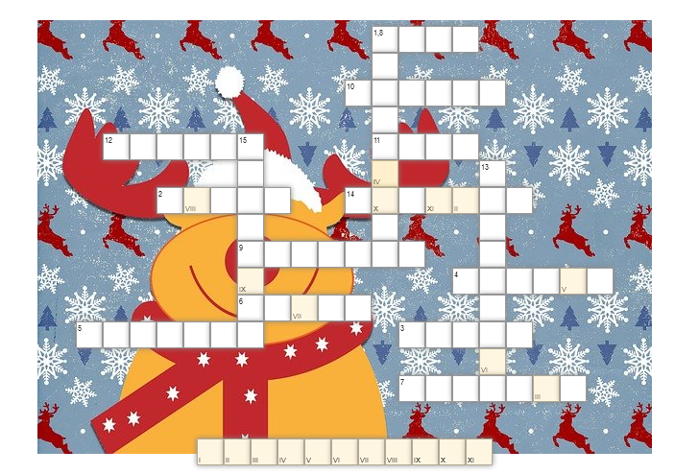

|  |  |  |  |
| --- | --- | --- | --- |
| **PIONOWO** | https://dbimg.eu/i/dl6xiaeopk.jpg | **9.** | https://dbimg.eu/i/yup12rpnjr.png |
|  | https://dbimg.eu/i/xqhtc9cwz8.jpg | **10.** | https://dbimg.eu/i/vds8xhohxl.jpg |
|  | https://dbimg.eu/i/ksfp5vl2nw.jpg | **11.** | https://dbimg.eu/i/z0rd6loc34.jpg |
|  | https://dbimg.eu/i/2g63lk8fos.jpg | **12.** | https://dbimg.eu/i/10eofzsnli.png |
|  | https://dbimg.eu/i/gujp25n2wz.png | **13.** | https://dbimg.eu/i/cqgfnxkkst.jpg |
| **6.** | https://dbimg.eu/i/kbb7q7qhfa.png | **14.** | https://dbimg.eu/i/2bswpriyvx.jpg |
| **7.** | https://dbimg.eu/i/t6gxza21rt.jpg | **15.** | https://dbimg.eu/i/0otvjkobh2.jpg |
| **8.**  **POZIOMO** | https://dbimg.eu/i/wzat6mjrjz.jpg |  |  |